horizontal line

**FuGen Group 2**

Gerrell Bones - [gbones2018@fau.edu](mailto:gbones2018@fau.edu)

Hayden Stone - [hstone2018@fau.edu](mailto:hstone2018@fau.edu)

Christopher Costa - [costa2018@fau.edu](mailto:costa2018@fau.edu)

Peyton Rivera - [privera2019@fau.edu](mailto:privera2019@fau.edu)

Ethan Welz - [ewelz2018@fau.edu](mailto:ewelz2018@fau.edu)

FALL 21’

CEN 4010 Principles of Software Engineering

CHEP’S

**YouTube Account: https://www.youtube.com/channel/UCvPAmQso4OCitvsxqbrGeqQ**

**DEMO LINK : https://www.youtube.com/watch?v=wycXkdVpj_Q**

**OVERVIEW / EXECUTIVE SUMMARY**

Chep’s is a social media site for campus to campus student’s. Our goal is to provide a world for our college students to share, interact with other students and universities across the U.S . It’ll be great for incoming freshmen to be able to interact with the college population to get to know the campus and lifestyle of different universities. Also it can be provided to spread awareness of things of social events, and be able to stay connected with people that have the same lifestyle as you. We understand that there are tons of social media sites to compare to, but our competitors will be tested through our niche market of one of the top content creators

# Competitive Analysis

| **Chep’s Features** | **Competitors Features** |
| --- | --- |
| Niche vital marketing group | Global Market |
| College business promotions | Ad Promotion |
| Specific marketing group | Established customer/ fan base |
| Personal and Long distance networking | Larger/Diverse marketing group |
| Specific information able to be carried to and from individuals | More Resources/Labor |

The advantages of having an inner circle social media platforms networking amongst upcoming entrepreneurs, similar majors, and people who work in places. You can end up upgrading your college experience by being able to connect with students from nearby universities and your own as well. The app is designed for students to just be free about the real side of college life with updates.

**Data Definition**

**user:**

| **Name** | **Definition** | **Type** |
| --- | --- | --- |
| **User ID (unique)** | **Unique ID for each user that is generated on login** | int |
| Name | First and last name of user | varchar |
| Email | Email of user | varchar |
| **University** | College Name 3 Options(FAU/FIU/FSU)  Can be used to sort feed by university | varchar/HTML Dropdown button with options |
| Username (Unique) | Username that uniquely identifies each user | varchar |
| BIO (field) | User can input bio a bio on their profile (optional) | text |
| Profile picture | User can upload an image to display on their profile (optional) | blob (max size 1MB) |
| Mascot | Image that displays on users profile based on university | blob (max size 1MB) |

**post:**

| **Name** | **Definition** | **Type** |
| --- | --- | --- |
| **Post ID** | **Unique ID for each post that is generated on submission** | int |
| Post text | User text input to display on post | text |
| Post Image | Image uploaded by user to display on post | blob |
| Post date | Date that post was created | varchar |
| Post likes | Number of times other users have like post | int |

# Overview

User’s of our product would use it to connect with other students both at their school and others. A club leader could post about meetings and events happening on campus to help promote their club and get more new members to join. A new student could ask where things are on campus or connect with others and make new friends. Students deciding which college they want to go to could look at colleges sections and see what kind of events are happening and what kind of environment that college provides.

**Use cases:**

| **Use Case** | **Sign up** |
| --- | --- |
| actors | User |
| Pre condition | · user has an internet connection |
| Basic path | 1. User visits webpage to sign up 2. User enters name, email, username, university, password and confirms password 3. User clicks signup button to create account |
| Alternative path and exceptions | · User enters invalid symbol in one of the inputs, return error  · User enters improper format in email input, return error  · User leaves any field blank, return error  · Users password input and confirmation are not the same, return error |

| **Use Case** | **Login** |
| --- | --- |
| actors | User |
| Pre condition | · user has an internet connection  · user has created an account |
| Basic path | 1. User visits webpage to log in 2. User enters username and password 3. User clicks login button to sign in |
| Alternative path and exceptions | · User enters invalid combination of username and password, return error |

| **Use Case** | **Create post** |
| --- | --- |
| actors | User |
| Pre condition | · user has an internet connection  · user has created an account  · user is logged in |
| Basic path | 1. User visits webpage to create post 2. User inputs text of post 3. User optionally uploads image to post 4. User clicks create post button |
| Alternative path and exceptions | · User’s image is too large, return error  · User leaves text field blank, return error |

| **Use Case** | **Update Profile** |
| --- | --- |
| actors | User |
| Pre condition | · user has an internet connection  · user has created an account  · user is logged in |
| Basic path | 1. User visits webpage to update profile 2. User can update bio by inputting text into the text form and clicking the update button 3. User can upload an image to their profile by clicking the button to update profile image 4. User can change university by inputting text into the text form and clicking the update button |
| Alternative path and exceptions | · User leaves field blank and clicks update, return error  · User’s image is too large, return error |

**High-Level functions**

## Create Account (1)

Users can create an account by entering name, email, username, university and password

## Login (1)

Users can login with their username or email and password

## Logout (1)

User can click logout button to log out, ends session

## Create Post (1)

User can create post to their feed with text input and option for image

## Campus Feed (1)

Campus will be the scroll feed of your university. You’ll be able to scroll and post updates of whatever you want on the CAMPUS feed.

## 5.1 Sort Feed (1)

Feed is sorted by users university, optionally a dropdown can be added to sort by other university feeds (2).

## 5.2 Like Post (2)

Users can click a button to like a user's post.

## 5.3 Comment Post (3)

Users can comment on other users' posts within the feed.

## Update profile (1)

User can update profile image, bio, and university

## REP YOUR MASCOT (1)

Rep your mascot is the way to choose from different universities/communities to be a part of.

**Non-Functional Requirements**

1. **Data Security**

Make sure that any private info of visitors is safe and not available to others. Currently passwords are hashed through php and only username and userid is stored in session.

1. **Performance**

The website should perform well with page loading times kept to a minimum. The most concerning page would be the feed page with many posts having images. Limiting the image size to 1mb for each post should help ensure the website performs in order.

1. **Scalability**

System should be scalable with increasing users creating more data load. Could be a concern on the frontpage where posts need to be limited due to large amounts of data.

1. **Usability**

User interface works properly, is simple and efficient to use.

**High-level system architecture**

**Software used:**

1. **GitHub**
2. **VISUAL STUDIO CODE / COMPILER**
3. **MySQL/phpMYAdmin**

**Languages used:**

1. **HTML/CSS**
2. **JAVASCRIPT**
3. **PHP**

**Browsers supported:**

A majority of browsers should be supported as long as they support Javascript/PHP/cookies. Main examples:

* Chrome
* Mozilla Firefox
* Edge
* Safari
* Internet Explorer
* Opera

**APIs:**

We are currently not using any APIs. This is subject to change as features are implemented.

**Frameworks/Licenses:**

No licensed frameworks have been implemented yet.

**Reset CSS Tool**: <https://meyerweb.com/eric/tools/css/reset/> - Public Domain

**Font used - Roboto**: <https://google.com/design/spec/resources/roboto-noto-fonts.html>

License: Apache License 2.0

**Database:**

users:

* usersID - int(11)
* usersName - varchar(128)
* usersEmail - varchar(128)
* usersUniversity - varchar(128)
* usersUID - varchar(128)
* usersPWD - varchar(128)
* usersImage - blob (1mb)
* usersBio - TEXT
* usersMascot - blob (1mb)

posts:

* postsId - int(11)
* postsText - TEXT
* postsImage - blob (1mb)
* postsDate - varchar(128)
* postsLikes - int(5)

**Media storage:**

Images and text of posts will be stored in the database. Images will be limited to a size of 1mb to improve performance. Video sharing is currently not supported. If later implemented, the best way would likely be to have it hosted on a website such as vimeo or youtube and embedded in the post.

**Search/filter architecture and implementation:**

The search algorithm will use the user's university connected to their account to sort their feed. Optionally a dropdown or search bar can be added to sort by other university feeds.

**Your API’s:**

Currently, no API’s have been created. If video/media share is later implemented, we could create an API to grab from youtube.

**Describe any significant non-trivial algorithm or process (like rating, ranking, automatic prioritizing of items etc.)**

One algorithm we are thinking of implementing is a post rating for the feed. Posts with higher likes will appear at the top of the feed and decay based on time and/or loss of interest.

**High-level system UML diagrams:**

UML High level class diagram:

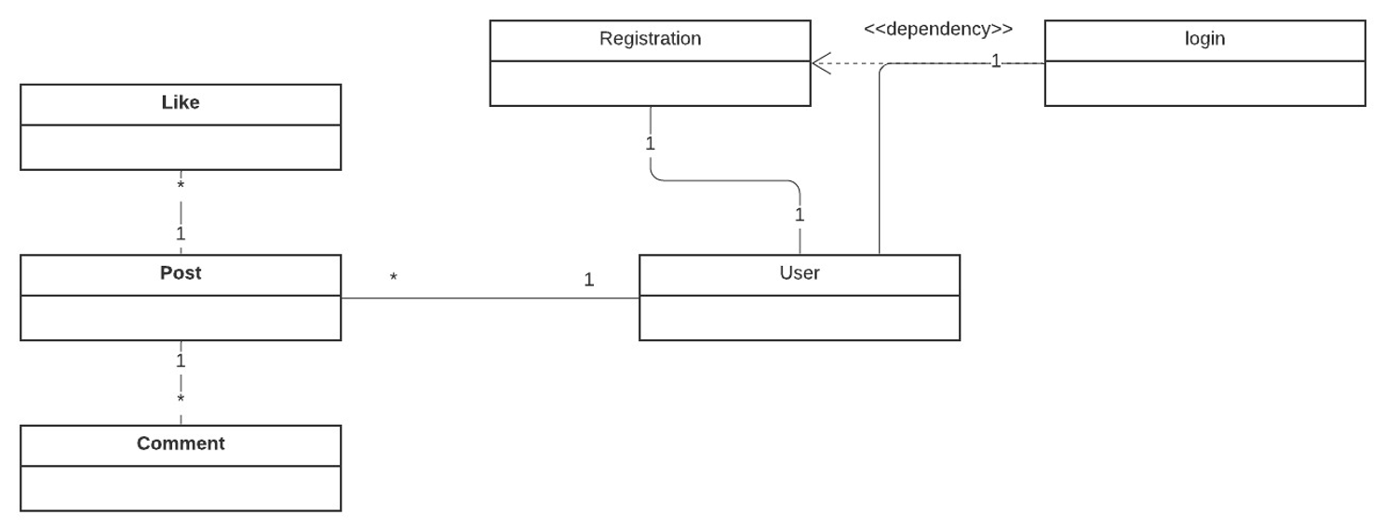

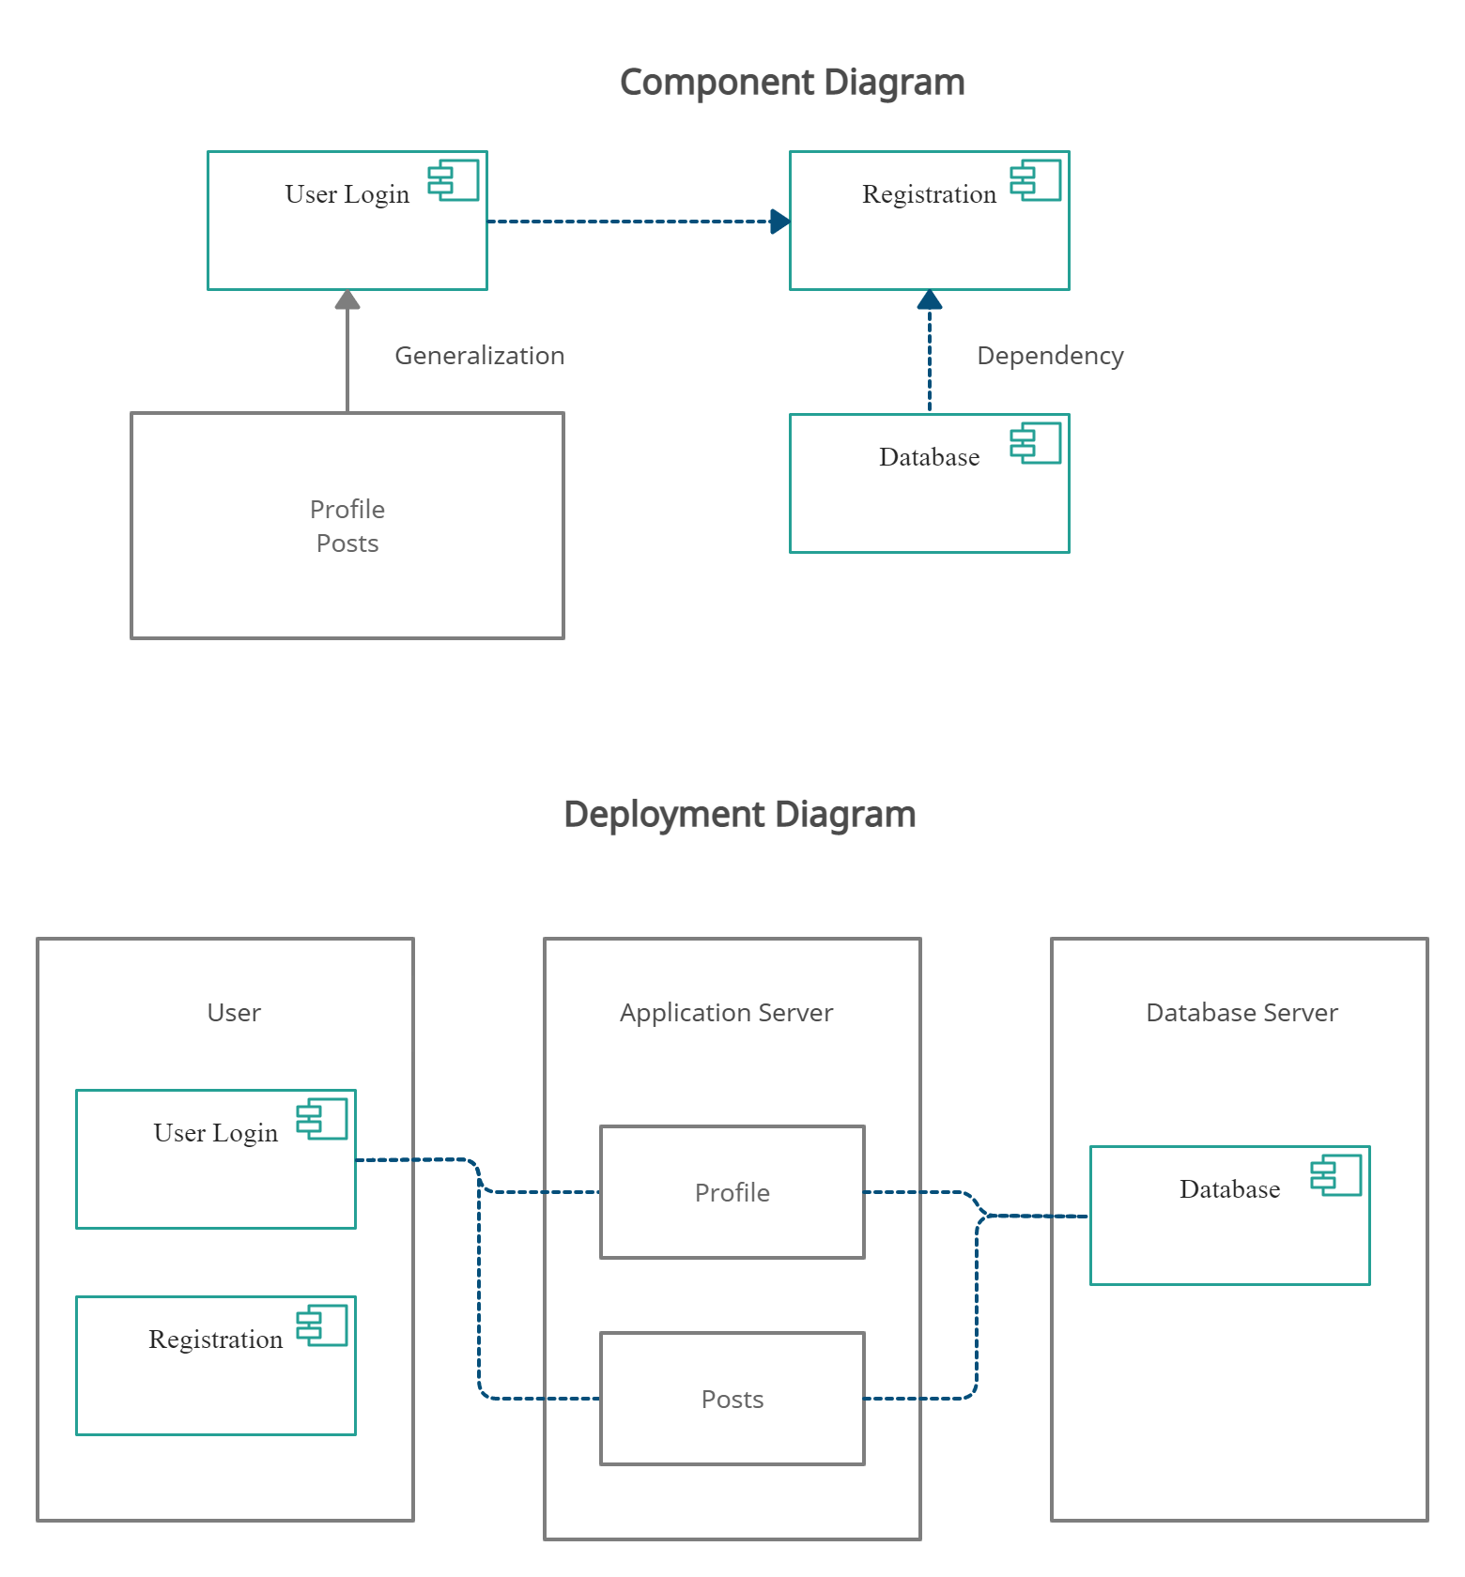

**Identify actual key risks for your project at this time:**

1. **Skill risks**

Some team members are less experienced with web development and all members are new to PHP. We believe that even with this setback, with the use of tutorials, guides and the vast amount of documentation on the web that we will be able to develop our project sufficiently.

1. **Schedule risks/Teamwork risks**

Currently our teamwork and scheduling is quite poor. We had declared days that would be proper to meet and discuss but have not done so. We will try and have a session to resolve said issues.

1. **Technical risks**

There are currently no known technical risks.

1. **Legal/content risks**

We currently have no legal risks regarding our project. Future legal/content risks will be avoided by using open source software/frameworks/code.